Setting up Oracle SQL Developer

1. Copy the folder called sqldeveloper
   1. P:\Corporate Trainers\Data_Analytic_Services
2. Paste the folder on your desktop or somewhere that suits you on your client
3. Open Folder
4. Double click on sqldeveloper.exe
5. Click on the Green plus for a new connection
   1. 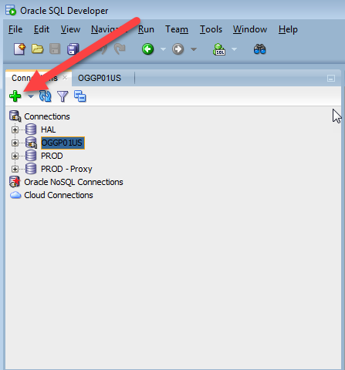
6. Configure your connection
   1. Connection_name: (any name you want: recommended RPT_MOD) for Oracle DB)
   2. User Name: lanname+[ALTERYX_RPT]
      1. Jdoe[ALTERYX_RPT]
   3. Password: Lan password. You will need to update this
   4. Hostname: oggp01us.db.costco.com
   5. Port: 1521
   6. Service name: OGGP01US

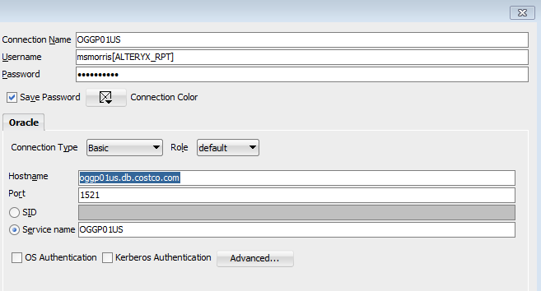

1. Click test to test your connection and then Save. If you currently cannot connect to RPT_MOD you may need to file a help desk ticket
2. Once your connection is saved you can Click on your connection in the connection pane and then select the Connect button.

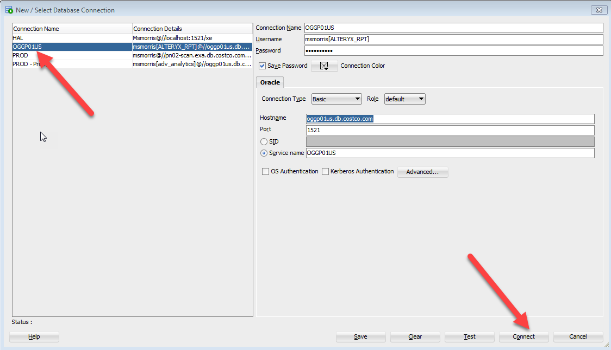

Navigating to RPT_MOD views

1. Right Click on your connection to expand the server view.
2. Choose Schema Browser
3. Scroll down and click on RPT_MOD

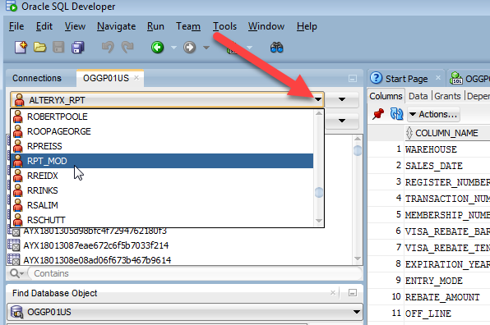

1. Next choose views

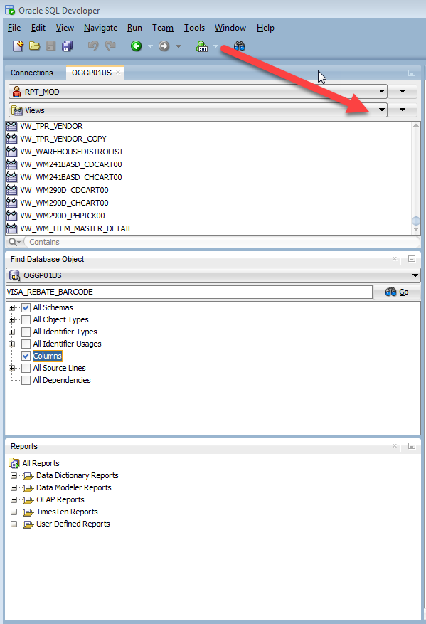

Creating a new SQL statement

1. Click on the SQL workbench icon

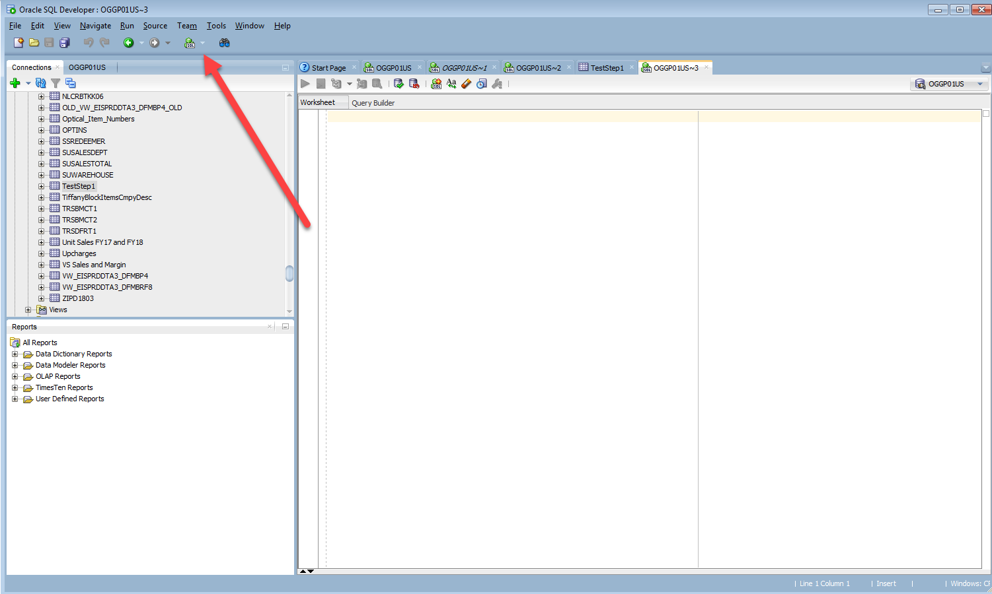

1. In the worksheet type your SQL code and click on the Green arrow to run
2. Right click on your data to export to excel